Mag Daddy Magnets: Innovation for Today

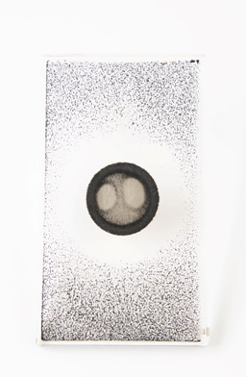
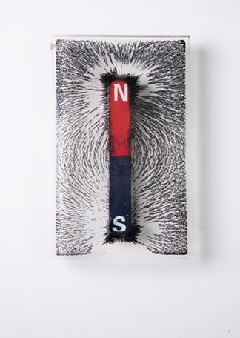
We’ll start out with the most important information: how do these magnets work? Magnets work around the concept of magnetic flux. Magnetic flux is basically the number of magnetic lines passing through a surface that creates the force we all think of when it comes to a magnet
Figure 1
(Figure 1.) Mag Daddy designs their magnets so that the magnetic flux is fully contained within the outer cup. This allows the north and south lines to redirect and not escape the magnet, which creates a superior strength and durability that reinforces with time. Crafted with neodymium, one of the strongest magnets in the world, Mag Daddy’s design is unparalleled. The cupping design of Mag Daddy products (Figure 2) makes for an innovative magnetic base that does not allow magnetic flux to escape meaning no data interference for extra sensitive projects.
Figure 2
Mag Daddy products aren’t your typical fridge magnets. These industrial strength magnetic hooks, clips, and fasteners find use in a variety of industries. For example, Mag Daddy sees high activity in security installations, automotive, electrical contracting, and more. A major reason for the versatility of these magnets is the industrial strength as well as the durability. In a lot of these industries, magnetic fasteners need to be able to withstand harsh environments. Mag Daddy products can withstand temperatures from -40° C to 176° C. This allows use in most environments year-round. Del City tested Mag Daddy magnets in a food service commercial freezer (Figure 3) and oven (Figure 4) to be sure they live up to their claims. As expected, Mag Daddy held up in these conditions. Being oil, grease, paint, and dirt resistant, these magnets can handle it all.
Figure 3
Figure 4
Although strength and durability are key factors in choosing a magnet, ease of use also needs to be considered. Mag Daddy prides themselves on their usability and convenience to the customer. Because of their strength, Mag Daddy products requiring no drilling or additional tools. This translates into both time and cost savings to the user. They are easy to uninstall if your plans change and you find yourself needing a magnet in a different location. For other possible changes, Mag Daddy products rotate 360° for versatility and convenience to the project. Coming in a large variety of shapes and sizes, Mag Daddy can fit where other fasteners and clips cannot. The unneeded drilling and welding help protect fragile environments for a cleaner installation.
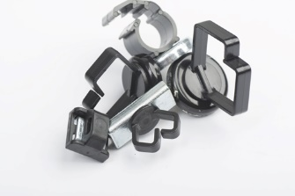
Mag Daddy as a company is recognized for both their innovative products as well as their overall success. Mag Daddy continues to see tremendous growth in multiple industries because of their unique and useful products. They were first recognized in 2013 by the National Electrical Contractors Association (NECA), winning the “Showstopper” award for their product line. Since then, Mag Daddy received awards in innovation from the Electronic Security Expo (ESX) multiple years in a row. The company grew 20% each year for the past three years while tracking to grow 25% in 2019. Mag Daddy doesn’t plan to slow down anytime soon with their expanding product lines and continuous improvement. Mag Daddy is proud to say once their customers join the family, they are usually a customer for life due to the high cost savings, durability, longevity, and ease of use of their product line. See Del City’s line of Mag Daddy products here. If you have any additional questions, please don’t hesitate to reach out to our team at 1-800-654-4757 or at info@delcity.net.

